

Semester Two Examination, 2020

Question/Answer booklet

MATHEMATICS METHODS
UNIT 3 & 4

Section Two:

Calculator-assumed

Your Name:
Your Teacher’s Name:

Time allowed for this section
Reading time before commencing work: ten minutes
Working time: one hundred minutes

Materials required/recommended for this section
To be provided by the supervisor
This Question/Answer booklet
Formula sheet (retained from Section One)

To be provided by the candidate
Standard items: pens (blue/black preferred), pencils (including coloured), sharpener, correction fluid/tape, eraser, ruler, highlighters

Special items: drawing instruments, templates, notes on two unfolded sheets of A4 paper, and up to three calculators approved for use in this examination

Important note to candidates
No other items may be taken into the examination room. It is your responsibility to ensure that you do not have any unauthorised material. If you have any unauthorised material with you, hand it to the supervisor before reading any further.

Question | Marks | Max | Question | Mark | Max
8 |  | 6 | 13 |  | 10
9 |  | 9 | 14 |  | 11
10 |  | 9 | 15 |  | 10
11 |  | 5 | 16 |  | 10
12 |  | 12 | 17 |  | 12

Structure of this paper

Section | Number of questions available | Number of questions to be answered | Working time (minutes) | Marks available | Percentage of examination
Section One:  Calculator-free | 7 | 7 | 50 | 50 | 35
Section Two:  Calculator-assumed | 10 | 10 | 100 | 94 | 65
 |  |  |  | Total | 100

Instructions to candidates

- The rules for the conduct of the Western Australian Certificate of Education ATAR course examinations are detailed in the Year 12 Information Handbook 2019. Sitting this examination implies that you agree to abide by these rules.

- Write your answers in this Question/Answer booklet.

- You must be careful to confine your answers to the specific questions asked and to follow any instructions that are specific to a particular question.

- Additional pages for the use of planning your answer to a question or continuing your answer to a question have been provided at the end of this Question/Answer booklet. If you use the space to continue an answer, indicate in the original answer space where the answer is continued, i.e. give the page number.

- Show all your working clearly. Your working should be in sufficient detail to allow your answers to be checked readily and for marks to be awarded for reasoning. Incorrect answers given without supporting reasoning cannot be allocated any marks. For any question or part question worth more than two marks, valid working or justification is required to receive full marks. If you repeat any question, ensure that you cancel the answer you do not wish to have marked.

- It is recommended that you do not use pencil, except in diagrams.

- The Formula sheet is not to be handed in with your Question/Answer booklet.

Section One: Calculator-assumed (94 Marks)

This section has ten questions. Answer all questions. Write your answers in the spaces provided.

Spare pages are included at the end of this booklet. They can be used for planning your responses and/or as additional space if required to continue an answer.
● Planning: If you use the spare pages for planning, indicate this clearly at the top of the page.
● Continuing an answer: If you need to use the space to continue an answer, indicate in the original answer space where the answer is continued, i.e. give the page number. Fill in the number of the question that you are continuing to answer at the top of the page.

Working time: 100 minutes.

Question 8 (6 marks)

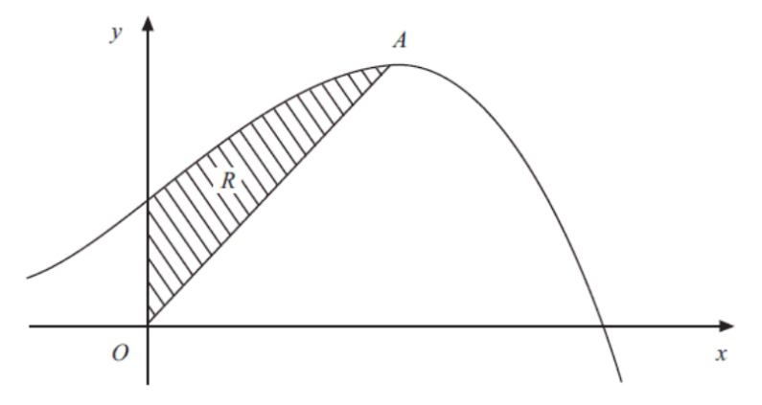
The diagram shows part of the curve with equation $y=10+8x+x^{2}-x^{3}$ and a maximum turning point at $A.$The region $R$ is bounded by the curve, the $y$ – axis and the line from $O$ to $A$, where $O$ is the origin.

- Using calculus, determine the coordinate of $A$. (3 marks)
$$\frac{dy}{dx}=8+2x-3x^{2}=0, x=-\frac{4}{3} \left(reject\right), x=2,$$
$$y=10+8\left(2\right)+2^{2}-2^{3}=22$$
$$Hence, A is (2, 22)$$
- Determine $\frac{dy}{dx}$
- Equate $\frac{dy}{dx}$ to 0 and solve for $x$
- State the coordinate

- Hence, find the exact area of $R$. (3 marks)

$$OA: y=11x$$
$$\int_{0}^{2}{10+8x+x^{2}-x^{3}-11x dx=\frac{38}{3}}$$

- Set up an integral using the difference of the functions
- Use the correct boundary points
- Calculate the correct exact area (no rounding)

Question 9 (9 marks)

Let $X$ be a random variable with PDF given by

$$f\left(x\right)=\left\{\begin{aligned}cx^{2} -1≤x≤1 \\ 0 otherwise\end{aligned}\right.$$

(a) Find the constant $c$. (2 marks)

$$1=\int_{-∞}^{∞}{f\left(x\right)dx=\int_{-1}^{1}{cx^{2}dx=\frac{2}{3}c}}$$

$$c=\frac{3}{2}$$

- Set up an integral and equate it to 1.
- Calculate the correct constant (2 marks)

(b) Find $E\left(X\right)$ and $Var\left(X\right).$ (5 marks)

$$E\left(X\right)=\frac{3}{2}\int_{-1}^{1}{xf\left(x\right) dx=\frac{3}{2}\int_{-1}^{1}{x^{3}dx=0}}$$

$$Var\left(X\right)=E\left(X^{2}\right)-{\left[E\left(X\right)\right]}^{2}=E\left(X^{2}\right)=\frac{3}{2}\int_{-1}^{1}{x^{2}f\left(x\right)dx=\frac{3}{2}\int_{-1}^{1}{x^{4} dx=\frac{3}{5}}}$$

- 2 marks each for correct answers
- 1 mark for showing working for both (integral with rule)

(c) Find $P(X≥\frac{1}{2})$ (2 marks)

$$P\left(X≥\frac{1}{2}\right)=\frac{3}{2}\int_{\frac{1}{2}}^{1}{x^{2}}dx=\frac{7}{16}$$

- Substitute the correct boundary points
- Calculate the correct probability

Question 10 (9 marks)

In a game at the Royal Show a player will pay to get five attempts to throw a ball at a target to win a prize. Of the last 500 throws, 91 of them hit the target.

(a) If one player hits the target three or more times in their five throws, they win a major prize. Calculate the probability that a player will win a major prize. State the distribution used and round your answer to four decimal places. (3 marks)

Solution
$$X\sim Bin(5, 0.182)$$
$$P\left(X≥3\right)=0.0450$$
Specific behaviours
- States Binomial distribution with the correct parameters
- Writes the probability statement correctly
- Obtains correct final answer to 4 decimal places

(b) One day, the owner of the game has only five major prizes. If 120 people play his game on that day, calculate the probability that he will not have enough major prizes to give out on the day. State the distribution used and round your answer to four decimal places. (3 marks)

Solution
$$Y\sim Bin(120, 0.045)$$
$$P\left(Y>5\right)=0.4554$$
Specific behaviours
- States Binomial distribution with the correct parameters
- Writes the probability statement correctly
- Obtains correct final answer (no need to round)

(c) On the same day, the owner promised his two children he would bring them back one major prize each. Given the owner had enough prizes to give out on the day, calculate the probability that he cannot fulfill his promise. Show working and round your answer to four decimal places. (3 marks)

Solution
$$P\left(Y≥4 | Y≤5\right)=\frac{P(4≤Y≤5)}{P(Y≤5)}$$
$$=\frac{0.3379}{1-0.4554}$$
$$=0.6202$$
Specific behaviours
- Sets up the correct conditional probability statement
- Correct numerator
- Correct denominator

Question 11 (5 marks)

Given that $x$and $y$ are legs of a right-angled triangle with hypotenuse 1, determine the largest possible value of the perimeter $p$of this triangle$.$

$$x^{2}+y^{2}=1$$

$$y=\sqrt{1-x^{2}}$$

$$p=x+\sqrt{1-x^{2}}+1$$

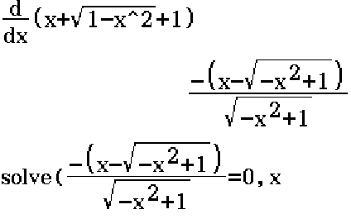
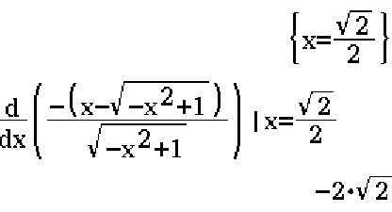
The 2nd derivative <0, $x=\frac{\sqrt{2}}{2}$ is a local maximum.
$$p=\frac{\sqrt{2}}{2}+\sqrt{1-{\left(\frac{\sqrt{2}}{2}\right)}^{2}}+1=\sqrt{2}+1 unit$$

- Determine an equation for $p$ in terms of $x$
- Determine $\frac{dp}{dx}$
- Equate $\frac{dp}{dx}$ and solve for $x$
- Justify why it is a local maximum
- Calculate the maximum $p$

Question 12 (12 marks)
A disease is spreading through trees in a forest. The instantaneous rate of change of the number $N$ of trees infected with respect to time $t$ is $\frac{dN}{dt}=0.18N$ trees/year. At the beginning of 2020 it is estimated that 1500 trees are infected.
- The formula below predicts the number $N$ of trees infected $t$ years after the beginning of 2020. Determine the values of $N_{0}$ and $k$. (2 marks)
$$N=N_{0}e^{kt}$$

- Using the formula:
(i) Determine the number (to the nearest integer) of infected trees 10 years after the beginning of 2020. (1 mark)

(ii) Determine the time taken (in years, to 2 decimal places) for the number of infected trees to double. (2 marks)

- Determine the yearly percentage increase in the number of infected trees (that is, the percentage by which the number of infected trees increases from the start of one year to the start of the next). Give your answer to 1 decimal place. (2 marks)

Environmental authorities consider introducing a program that involves spraying the forest with a treatment chemical, with the first treatment at the start of 2021. The spray has been shown to change the instantaneous rate of infected trees to a negative 5% of the population.

- Determine the predicted number of infected trees at the start of 2025. (2 marks)

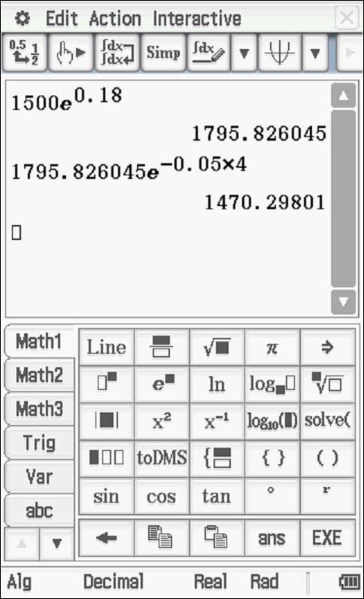
(1 Mark) Determine number at start of 2021
(1 Mark) Determine value at start of 2025 using new exponential model

- Since the start of the spraying, determine the time taken for the number of infected trees to halve in number. (3 marks)

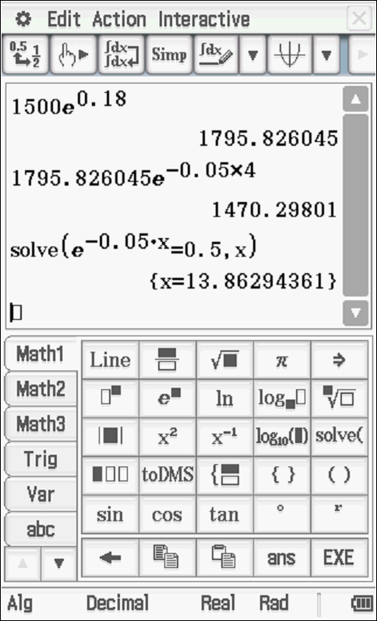
(1 mark) realise that time taken to halve is independent of starting value
(1 mark) set up equation to solve for time
(1 mark) solves for time

Question 13 (10 marks)

A production company wants to determine how popular their film will be when it hits the box office. To do this they used a 10 focus groups, each with 300 participants as samples. In the first of these focus groups 215 people liked the film and the remainder did not.

(a) State two ways that the production company could increase the accuracy of their sampling. (2 marks)

Solution
Increase the number of participants in each focus group/sample
Increase the number of samples
Specific behaviours
- State one correct way
- State two correct ways

For the first focus group:
(b) Calculate the sample proportion of people who liked the film to four decimal places. (1 mark)
Solution
$$\hat{p}=215/300$$
$$=0.7167$$
Specific behaviours
- Calculates the correct proportion

(c) Determine the 95% confidence interval for the proportion of people who liked the film to four decimal places. (3 marks)
Solution
$$\left(0.7167-1.96\sqrt{\frac{0.7167\left(1-0.7167\right)}{300}},0.7167+1.96\sqrt{\frac{0.7167\left(1-0.7167\right)}{300}}\right)$$

$$\left(0.6657, 0.7677\right)$$

Specific behaviours
- Uses Z = 1.96
- Calculates confidence interval
- Shows use of formula for confidence interval

(d) What is the margin of error of the 95% confidence interval? (2 marks)
Solution
$$E=1.96\sqrt{\frac{0.7167\left(1-0.7167\right)}{300}}$$
$$=0.0510$$
Specific behaviours
- Calculates the margin of error
- Shows use of formula

(e) With an example calculation, comment on the relationship between confidence and margin of error. (2 marks)

Solution
For a 99% confidence interval
$$E=2.576\sqrt{\frac{0.7167\left(1-0.7167\right)}{300}}$$
$$=0.0670$$

Therefore, increasing the confidence increases the margin of error.

Specific behaviours
- Determines the correct relationship i.e. increasing confidence increases the margin of error.
- Justifies answer by determining the margin of error for a different confidence interval or comparing the Z values for different confidence intervals.

Question 14 (11 marks)

The lengths of the needles of the Aleppo pine, in cm, are Normally distributed with mean $μ$. It is further known that 11.51% of these pine needles are shorter than 5.7 cm and 3.59% are longer than 9.8 cm.

(a) Represent the information above in the graph below. (3 marks)
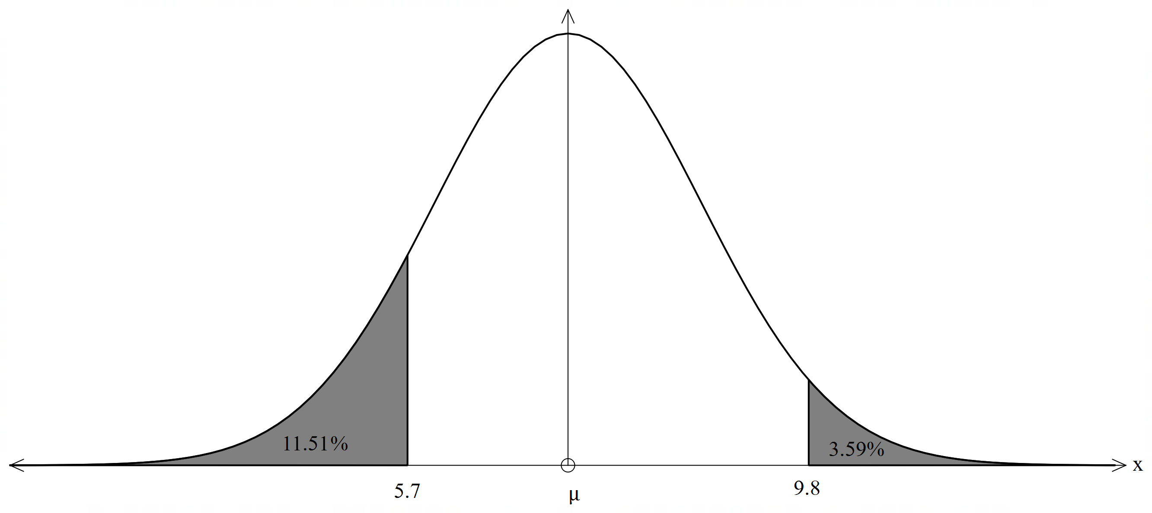
Specific behaviours
labelling the centre as the mean
correct areas shaded
label for areas shaded with the measurements on the x axis

(b) Find the mean and standard deviation of the lengths of the pine needles. (4 marks)
Solution
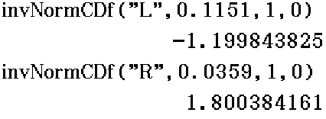

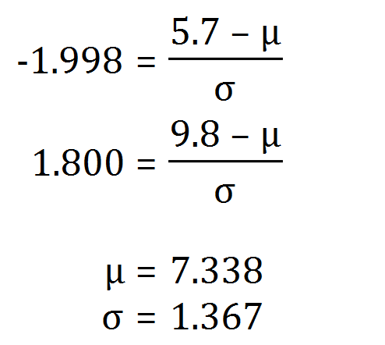
Calculate both z scores
Set up equations for z scores with mean and standard deviation
Calculate the correct mean
Calculate the correct standard deviation

(c) If 8 pine needles are selected, what is the probability that 5 of the needles will have measurements between the minimum and maximum lengths of the middle 40% of pine needle lengths? (4 marks)

Solution
Minimum length: 6.62
Maximum length: 8.05

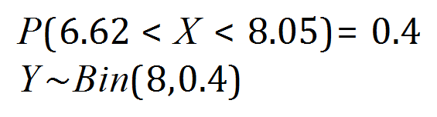
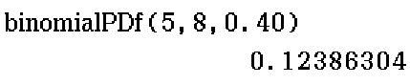
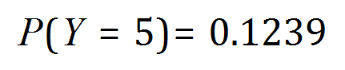
Determine the lengths of the middle 40%
Determine the probability that a pine needle will have lengths within this interval
Determine a binomial distribution
Determine the probability of exactly 5 pine needles within the given interval length

Question 15 (10 marks)
A random sampling of a large collection of widely shared social media posts was conducted by a year twelve student at Perth Modern School. Out of 572 randomly selected posts, the student found that 293 contained false or misleading information.
- Show how the student used the above information to calculate a 99% confidence interval for the population proportion to be (0.458,0.566)
(5 marks)
Solution
$$\hat{p}=\frac{293}{572}≈0.5122$$

$$σ_{\hat{p}}=\sqrt{\frac{\left(\frac{293}{572}\right)\left(1-\frac{293}{572}\right)}{572}}≈0.0209$$

$$z_{0.99}≈2.576 \\ E=2.576×0.0209≈0.0538$$

$$0.5122±0.0538=\left(0.45840, 0.5660\right)≈(0.458, 0.566)$$

Specific behaviours
- Shows sample proportion
- Shows standard deviation
- Shows $z$-score for $99\%$
- Uses the $z$-score to determine margin of error
- Uses margin of error to calculate confidence interval

- State whether each of the statements below is true or false with a reason based on the information given above.
  - If the student conducted random sampling repeatedly, then the true proportion of false or misleading information will fall between 0.458 and 0.566 ninety-nine percent of the time.
(1 mark)
Solution
False with a valid reason
Specific behaviours
States false as any one CI may not include true value at all.

  - The probability that the true proportion of false or misleading information falls between 0.458 and 0.566 is 0.99. (1 mark)
Solution
False as 0.99 refers to expected % of repeated CIs constructed that would be expected to contain true proportion
Specific behaviours
States false with a valid reason

- Another student is about to take a random sample of social media posts. The student is aiming for a margin of error of approximately 0.02 for a 99% confidence interval. How many posts, to the nearest 10, should the student include in the sample? (3 marks)

Solution
$$0.02=2.576\sqrt{\frac{0.51224\left(1-0.51224\right)}{n}}$$
$$n≈4144.87$$
The student should include 4145 posts
Specific behaviours
- Uses correct calculation method
- Correct sample size
- Rounds up to nearest integer

Question 16 (10 marks)

A variable star is a type of star whose brightness fluctuates. One such star can reach its minimum and maximum brightness within the interval $0≤t≤6.1$, where $t$ is in days. The average brightness of the star is $C$ at $t=0$, which changes by $±a$. The brightness of the star, after $t$ days, is given by:
$$B\left(t\right)=a\sin{\frac{2πt}{6.1}}+C$$

(a) Show the use of calculus techniques to determine the values of $t$ where the star will reach its minimum and maximum brightness, and state which value of $t$ will give this minimum and maximum. (4 marks)
$$B\left(t\right)=a\sin{\frac{2πt}{6.1}}+C$$

$$B^{'}\left(t\right)=\frac{2πa}{6.1}\cos{\frac{2πt}{6.1}}$$

$$0=\frac{2πa}{6.1}\cos{\frac{2πt}{6.1}}$$

$$\frac{2πt}{6.1}=\frac{π}{2} or\frac{3π}{2}$$

$$t=1.525 or 4.575$$

$$B^{''}\left(t\right)=-\frac{4π^{2}a}{{6.1}^{2}}\sin{\frac{2πt}{6.1}}$$

$$-\frac{4π^{2}a}{{6.1}^{2}}\sin{\frac{2π\left(1.525\right)}{6.1}}<0$$

$$-\frac{4π^{2}a}{{6.1}^{2}}\sin{\frac{2π\left(4.575\right)}{6.1}}>0$$

$∴t=1.525$ gives the MAXIMUM brightness
$t=4.575$ gives the MINIMUM brightness

- Determine first derivative
- Equate the first derivative to 0 and solve for $t$
- Use second derivative or otherwise justify why min and maximum
- State conclusions
(b) The star has a brightness of 4.9 at approximately $t= 0.79$. The rate of change in brightness for the star at this point is approximately 0.389. Determine the value of $a$ to 2 decimal places, and hence determine the function $B(t)$. (3 marks)
$$0.389=\frac{2πa}{6.1}\cos{\frac{2π(0.79)}{6.1}}$$
$$a=0.55$$
$$4.9=C+0.55\sin{\frac{2π\left(0.79\right)}{6.1}}$$

$$C=4.5$$
$$∴B\left(t\right)=4.5+0.55\sin{\frac{2πt}{6.1}}$$
- Set up an equation and solve for $a$
- Hence solve for $C$
- State the function $B\left(t\right)$

(c) Use the incremental formula at $t=1.2$ to estimate the change in brightness for a 3-hour change in time. (3 marks)
$$B'\left(1.2\right)=\frac{11π}{61}\cos{\frac{2π(1.2)}{6.1}=0.186}$$

$$δB≈\frac{dB}{dt}×δt$$
$$≈0.186×\frac{3}{24}$$
$$≈0.0233$$

The approximate change in brightness is 0.0233

- Determine $B^{'}\left(1.2\right)$
- Demonstrate the use of the incremental formula
- Calculate the approximate change

Question 17 (12 marks)

The following diagram shows the graph of $y=f(x)$, where $f\left(x\right)$ is a quarter circle for $1≤x≤2$ and a semicircle for $5≤x≤7.$
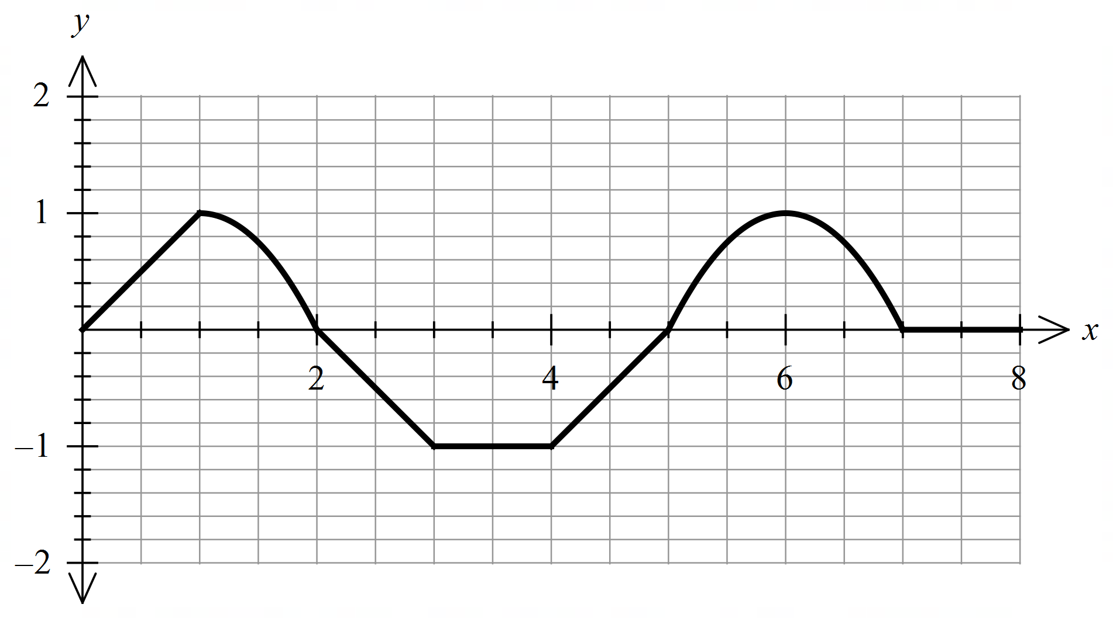
Let $F(x)$ be the antiderivative of$f(x)$ and given that $F(0)=-1$, and that $f\left(x\right)=0$for
$x≤0$and$x≥7$.

(i) Determine the intervals where $F(x)$ is increasing and decreasing, respectively.
(2 marks)

$$Increasing on \left(0, 2\right) and \left(5, 7\right); decreasing on (2, 5)$$

- Correct intervals for increasing
- Correct intervals for decreasing

(ii) Determine the intervals where $F(x)$ is concave up and concave down, respectively.
(2 marks)

$$Concave up at (0,1) and (4, 6); concave down at (1, 3) and (6, 7); neither at (3, 4)$$

- Correct intervals for concave up
- Correct intervals for concave down

(iii) Determine the value(s) of $x$ when $F\left(x\right)$reaches the local maximum and local minimum, respectively. (2 marks)

$$A local maximum at x=2 and a local minimum at x=5$$

- Correct $x$ for local max
- Correct $x$ for local min

(iv) Determine the exact value of $F(1)$. (2 marks)

$$\int_{0}^{1}{f\left(x\right) dx=F\left(1\right)-F\left(0\right)=\frac{1}{2}, F\left(1\right)=\frac{1}{2}+F\left(0\right)=-\frac{1}{2}}$$

- Demonstrate the use of F.T.C
- Calculate the correct answer

(v) Determine the exact value of $F\left(7\right).$ (4 marks)

$$\int_{0}^{7}{f\left(x\right) dx=F\left(7\right)-F\left(0\right)=\frac{1}{2}+\frac{π}{4}-\frac{1}{2}-1-\frac{1}{2}+\frac{π}{2}=\frac{3π}{4}-\frac{3}{2}}$$
$$F\left(7\right)=\frac{3π}{4}-\frac{3}{2}+F\left(0\right)=\frac{3π}{4}-\frac{5}{2}$$

- Demonstrate the use of F.T.C
- Calculates the value of the integral from x = 0 to x = 7
- Substitutes the value of F(0)
- Calculate the correct answer

Additional working space
Question number: _______

Additional working space
Question number: ________

Additional working space
Question number: ________

